Assignment-2
Task-1
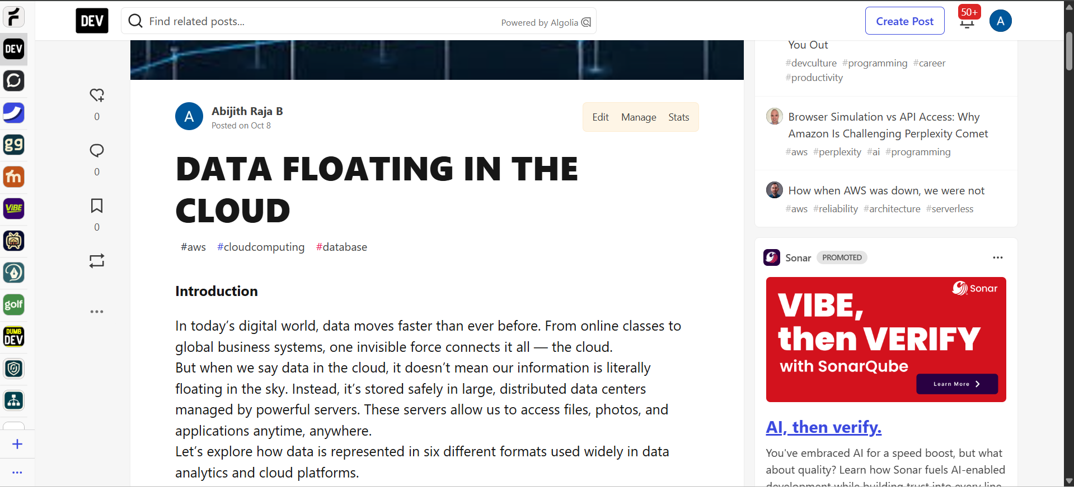

Link: https://dev.to/abijith_rajab_7dc1ac8d79/data-floating-in-the-cloud-2m30

Task-2
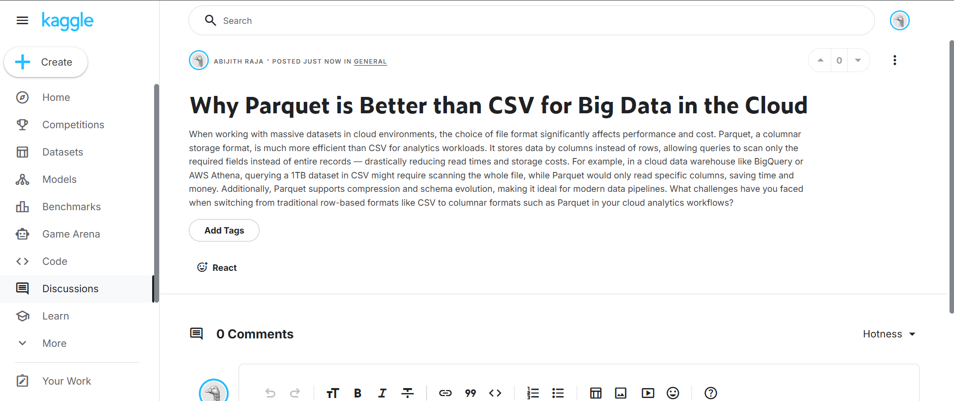
Link: https://www.kaggle.com/discussions/general/615203

Task-3
